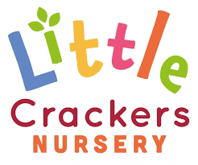 3rd July 2020
Weekly News

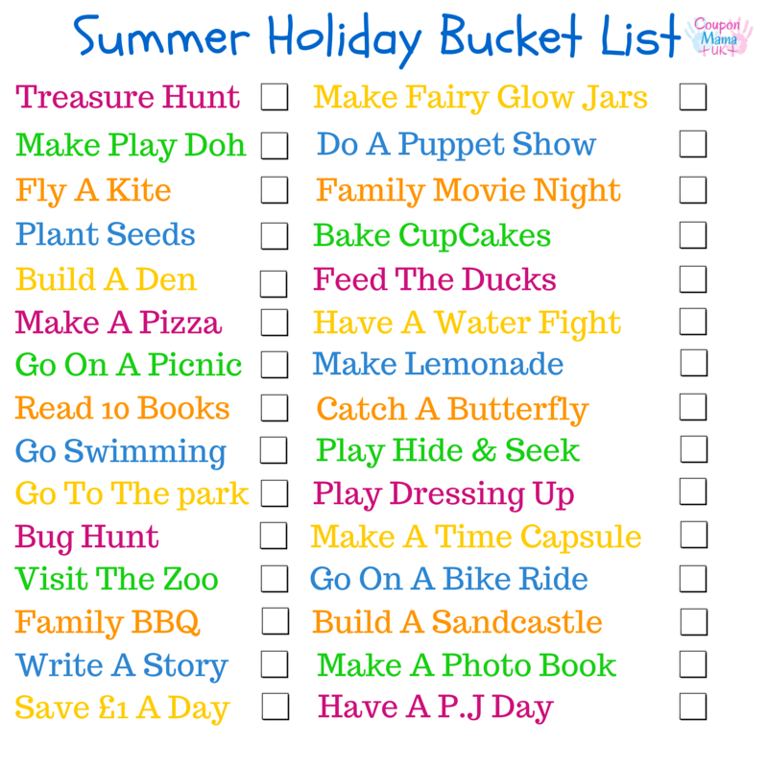 |  | 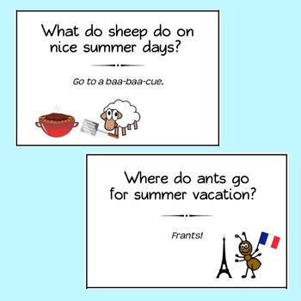
‘Crazy Little Crackers’ modelling the new t-shirts!!! | To all our Little Crackers,  Have a wonderful summer everyone – it’s been great catching up with some of you after lockdown, and we can’t wait to see the rest of you in September…  And a special great big hug goes to our badgers who are moving on to new classes in September – we wish you all the very best,  we’ll miss you…  With love from us all x

Little Crackers Nursery · Crackley Hall · St Joseph’s Park · Kenilworth · CV8 2FT
Telephone: 01926 514444 · Fax: 01926 514455 · e-mail: littlecrackers@crackleyhall.co.uk
www.crackleyhall.co.uk

Registered Charity Number 1087124 Company limited by guarantee Number 4177718

